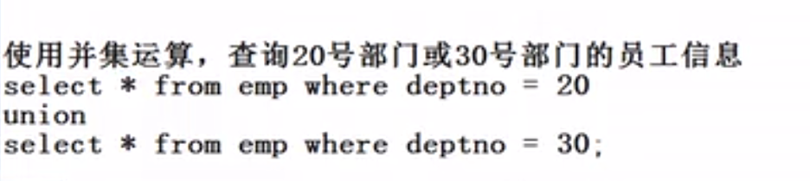

**select * from emp where deptno=20 union select * from emp where deptno=30; (使用select * from emp where deptno in(20,30)岂不是更好？)**

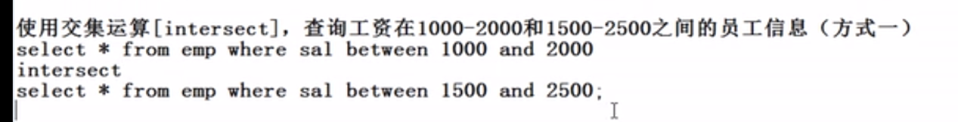

**select * from emp where sal between 1000 and 2000 intersect select * from emp where sal between 1500 and 2500;**

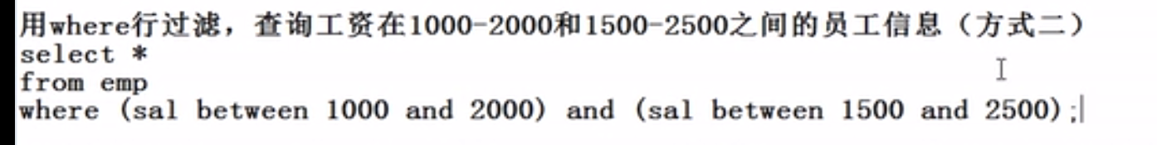

**select * from emp where (sal between 1000 and 2000) and (sal between 1500 and 2500);**

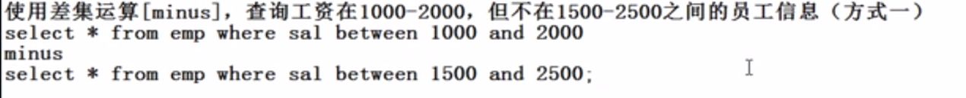

**select * from emp where sal between 1000 and 2000 minus select * from emp where sal between 1500 and 2500;**

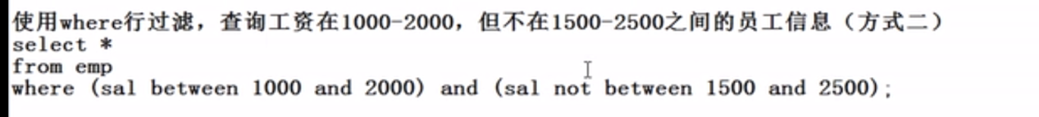

**select * from emp where (sal between 1000 and 2000) and (sal not between 1500 and 2500);**

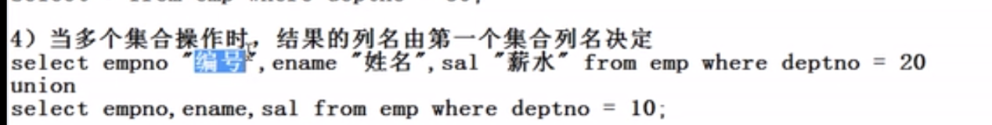

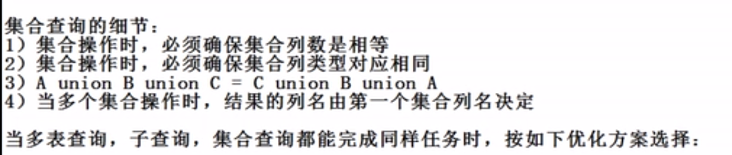



**即：优先采用多表查询，其次是子查询，最后才是集合查询**